

**Key Vocabulary**

**Year 3/4 French Greetings with Puppets**

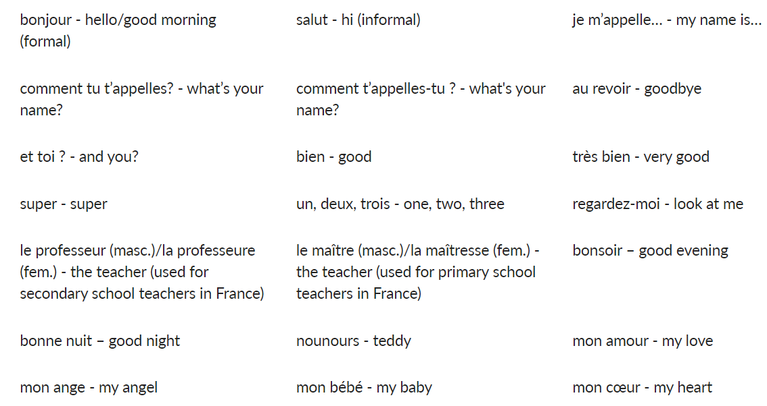

******Key Vocabulary**

**Year 3/4 Adjectives of Colour, Size and Shape**

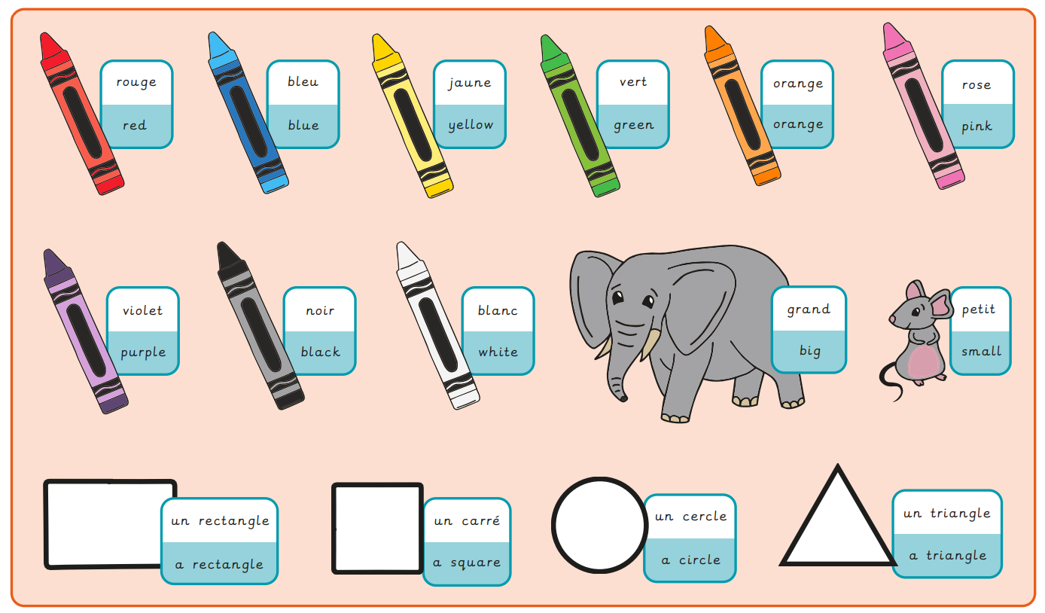

**Key Vocabulary**

**Year 3/4 Playground Games and Numbers**

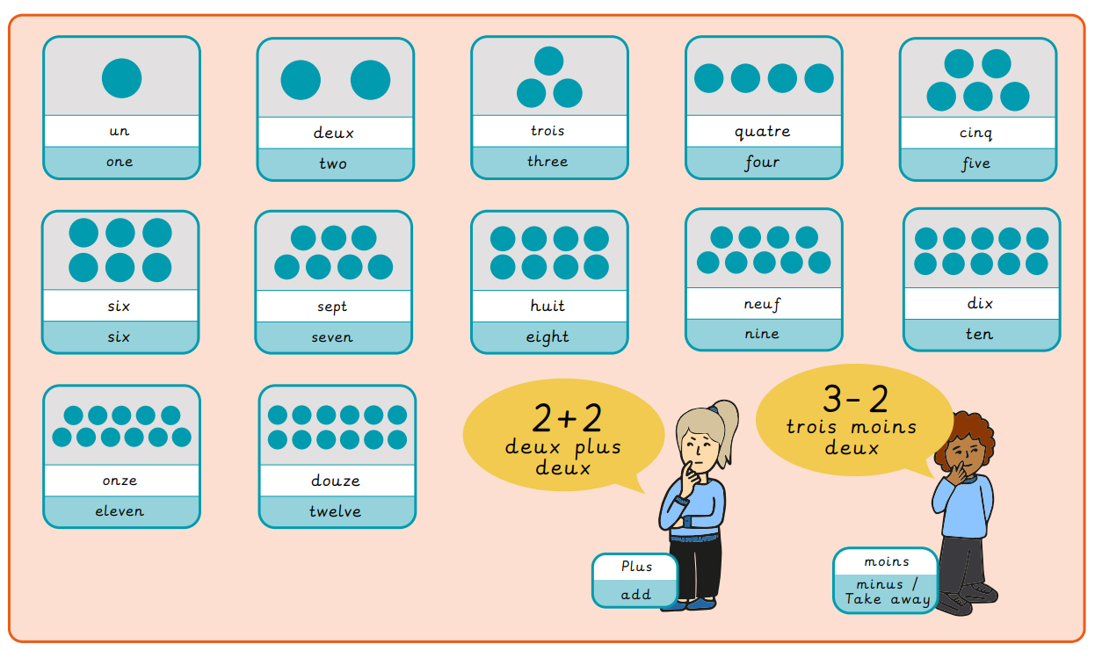

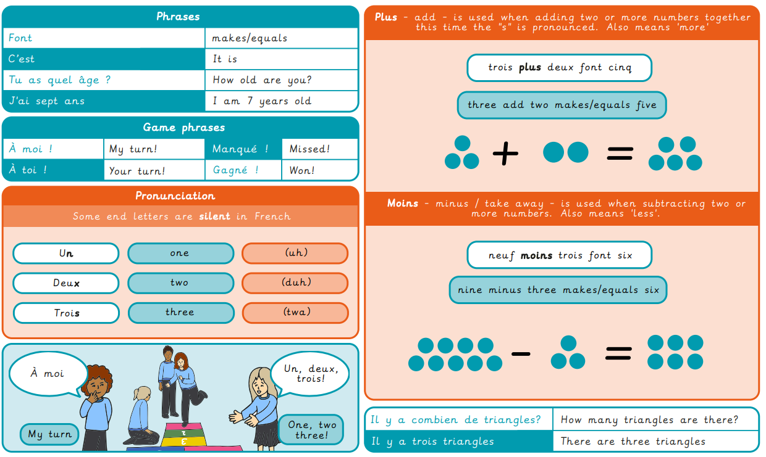

**Key Vocabulary**

**Year 3/4 In a French Classroom**

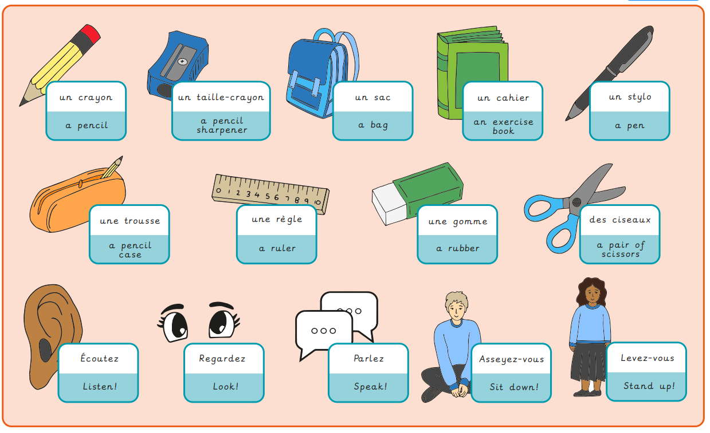

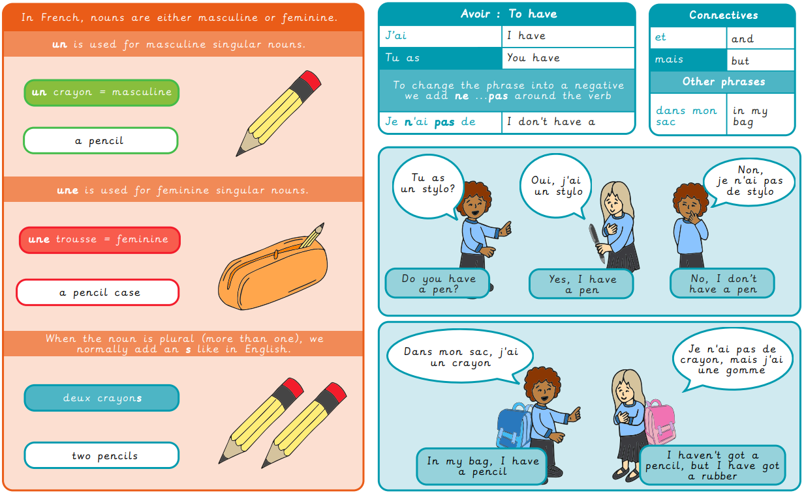

**Key Vocabulary**

**Year 3/4 Transport**

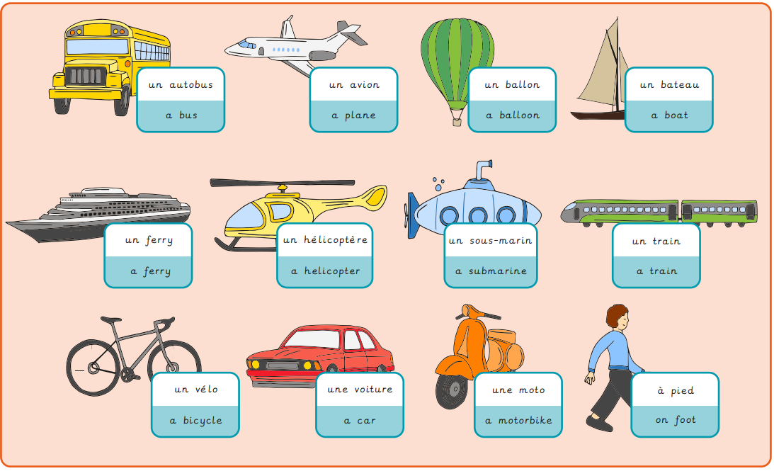

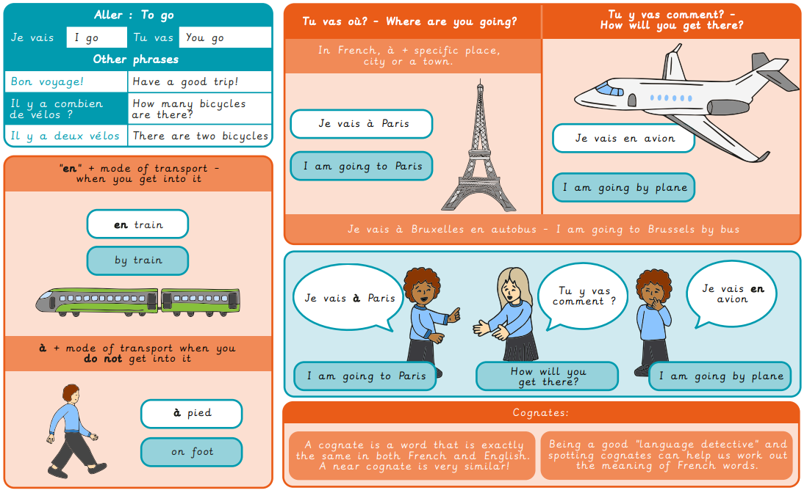

**Key Vocabulary**

**Year 3/4 A Circle of Life**

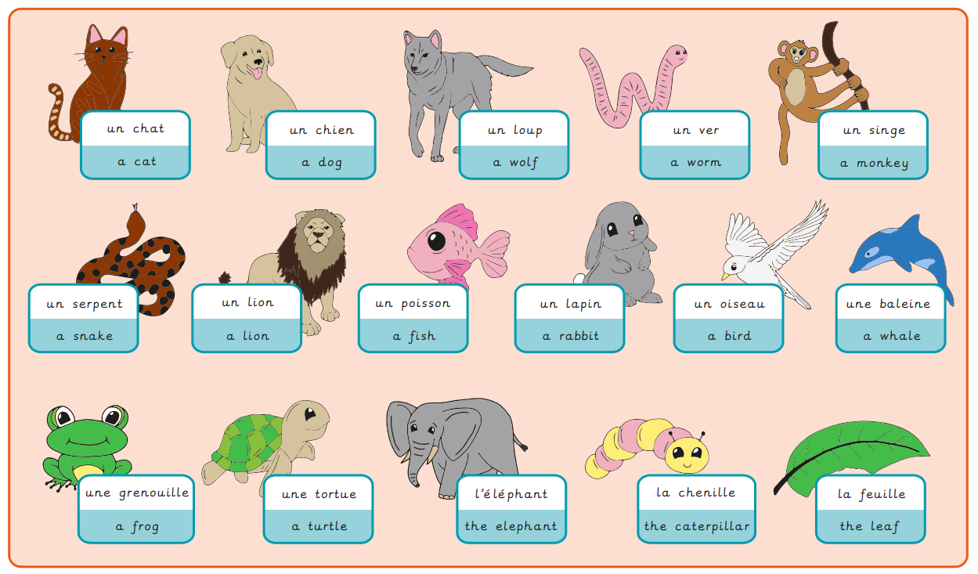

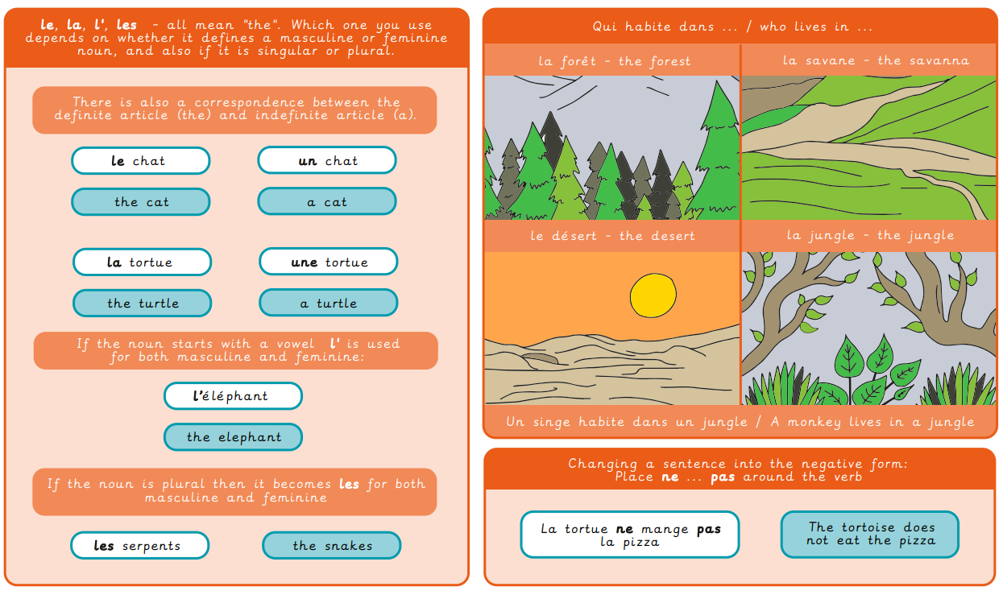

**Key Vocabulary**

**Year 3/4 Bon Appetit**

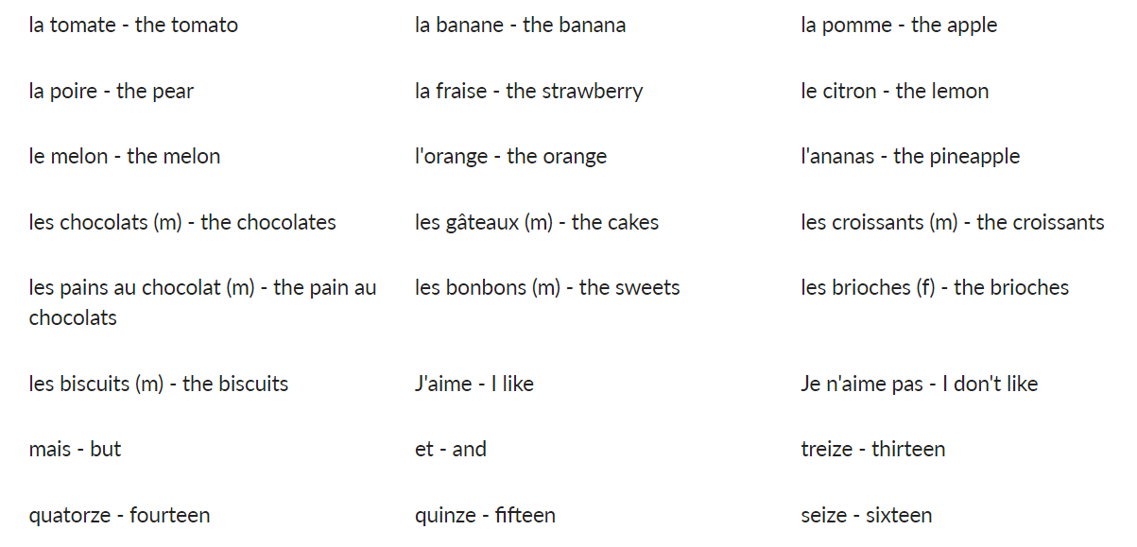

**Key Vocabulary**

**Year 3/4 Bon Appetit- Shopping for French Food**

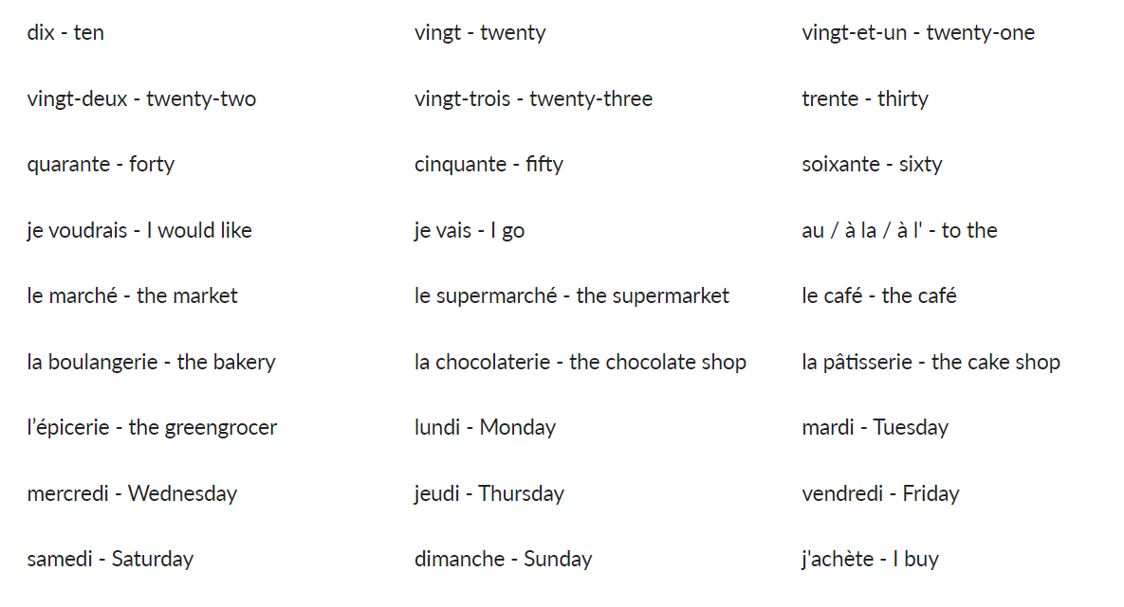

**Key Vocabulary**

**Year 3/4 This is Me**

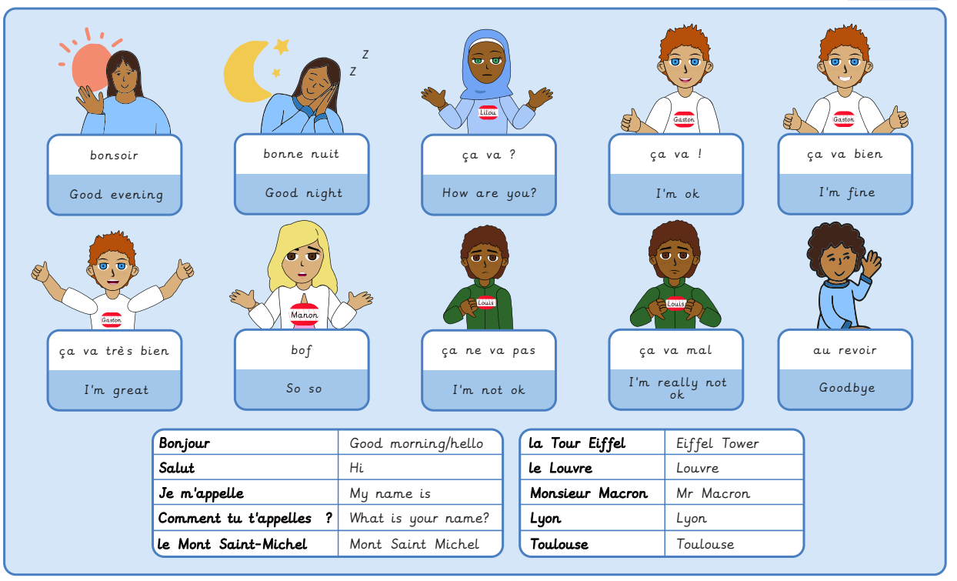

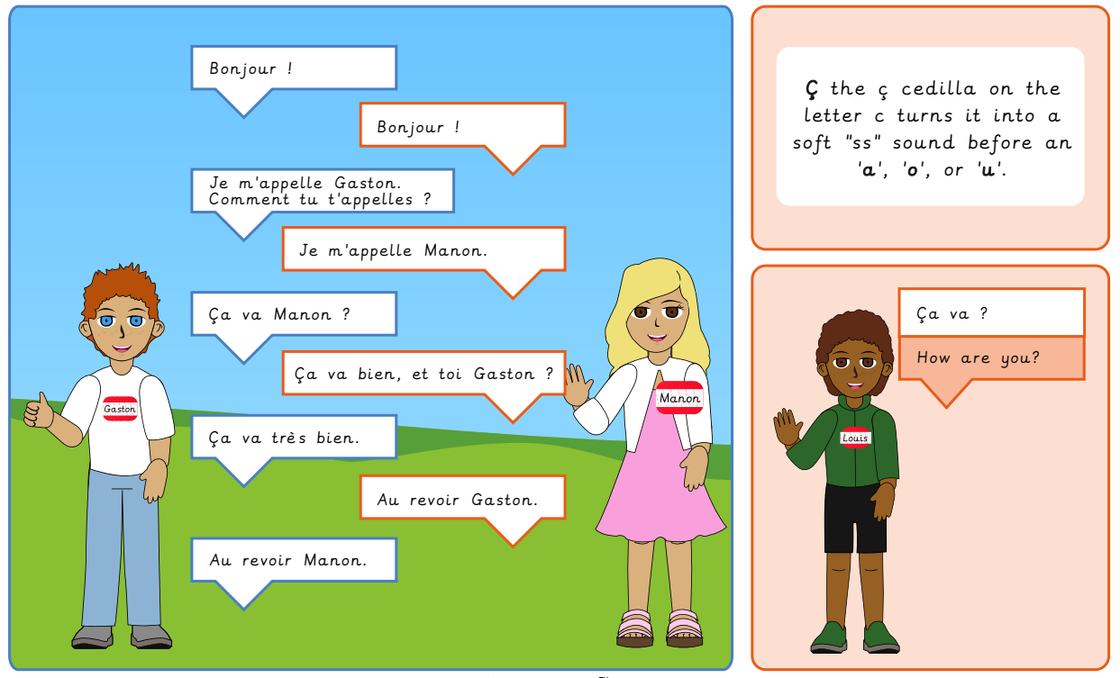

**Key Vocabulary**

**Year 3/4 School Days**

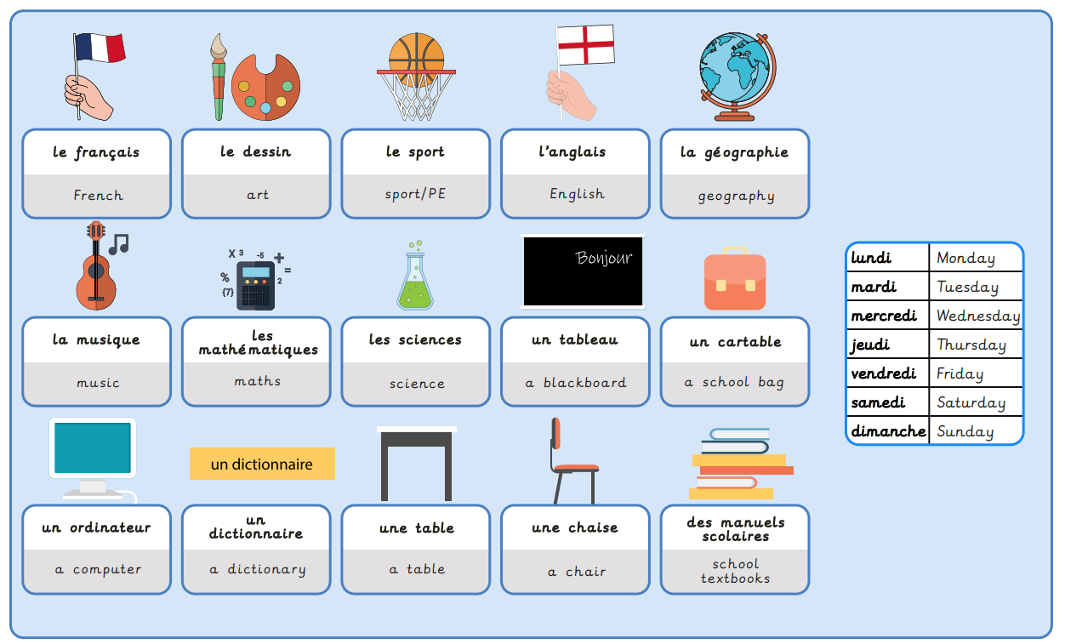

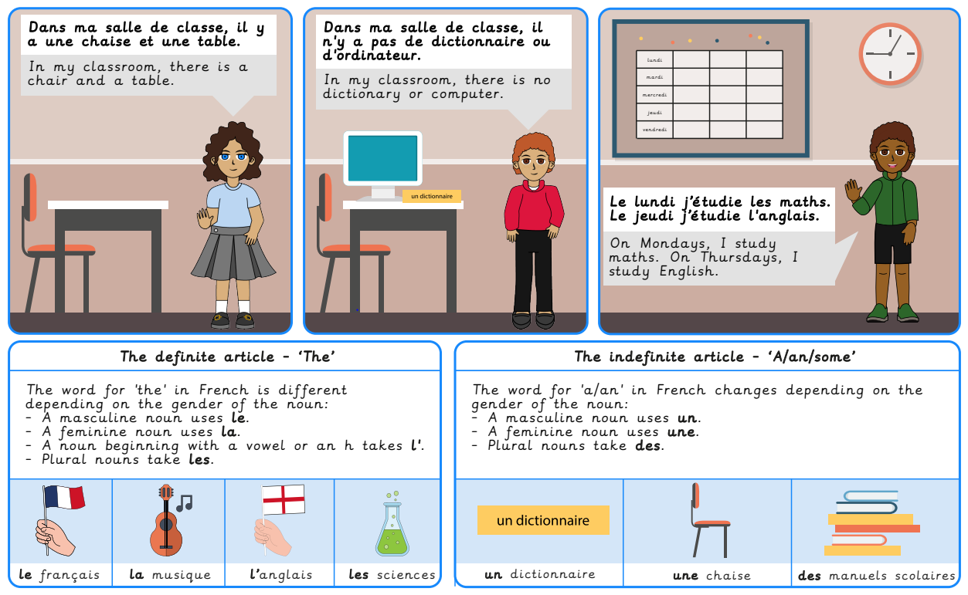

**Key Vocabulary**

**Year 3/4 Birthday Celebrations**

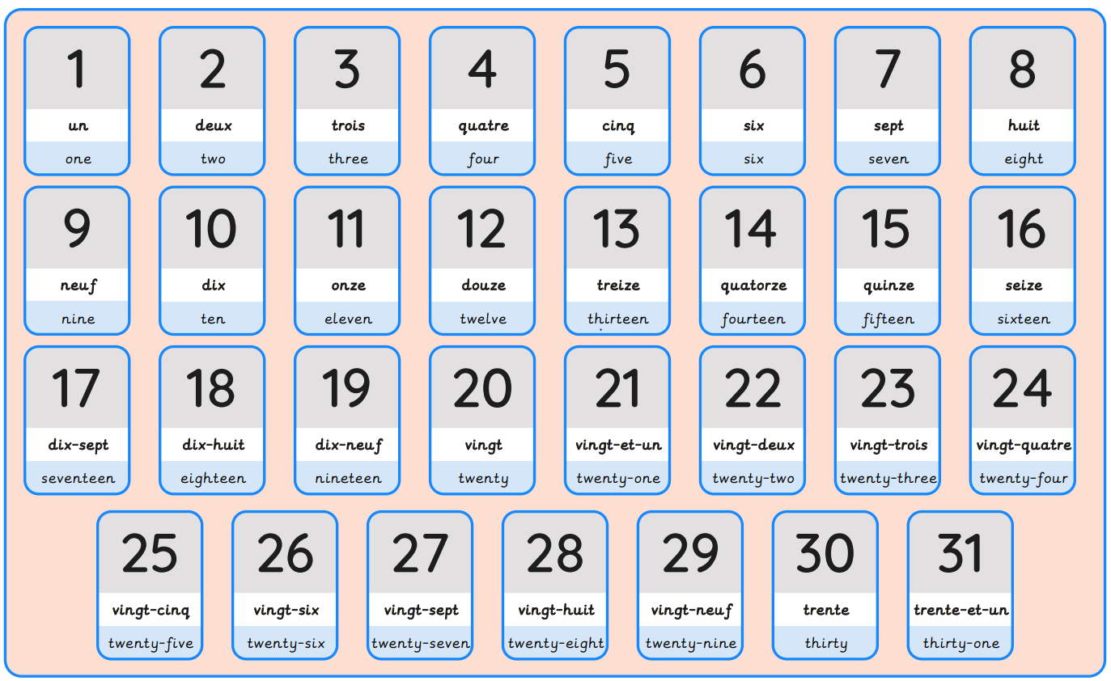

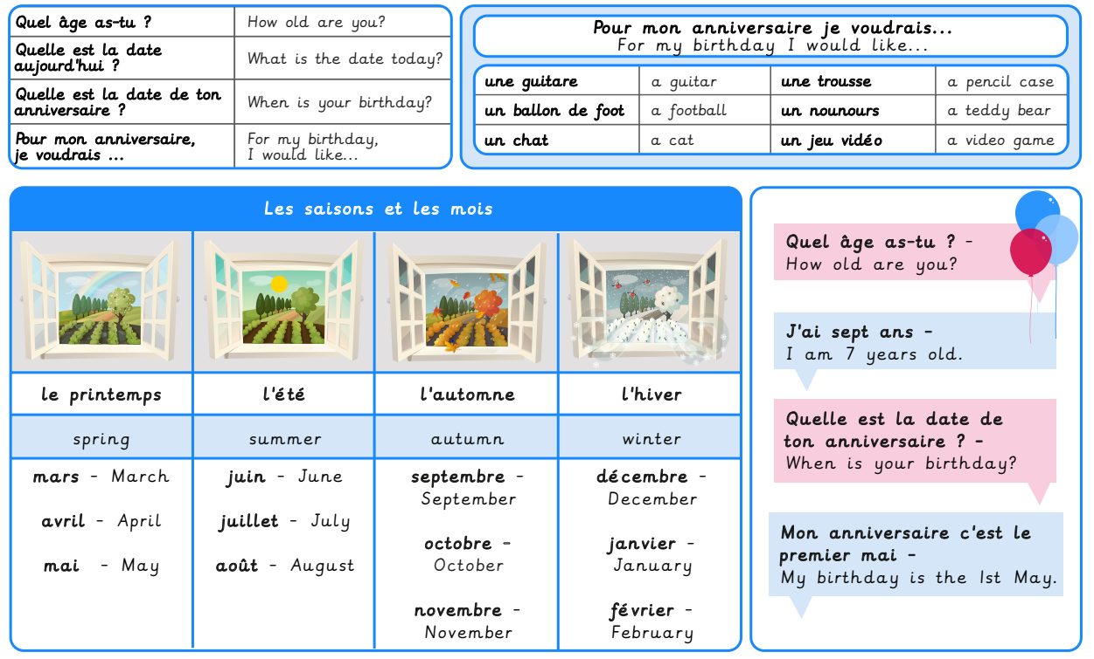

**Key Vocabulary**

**Year 3/4 Colourful Creatures**

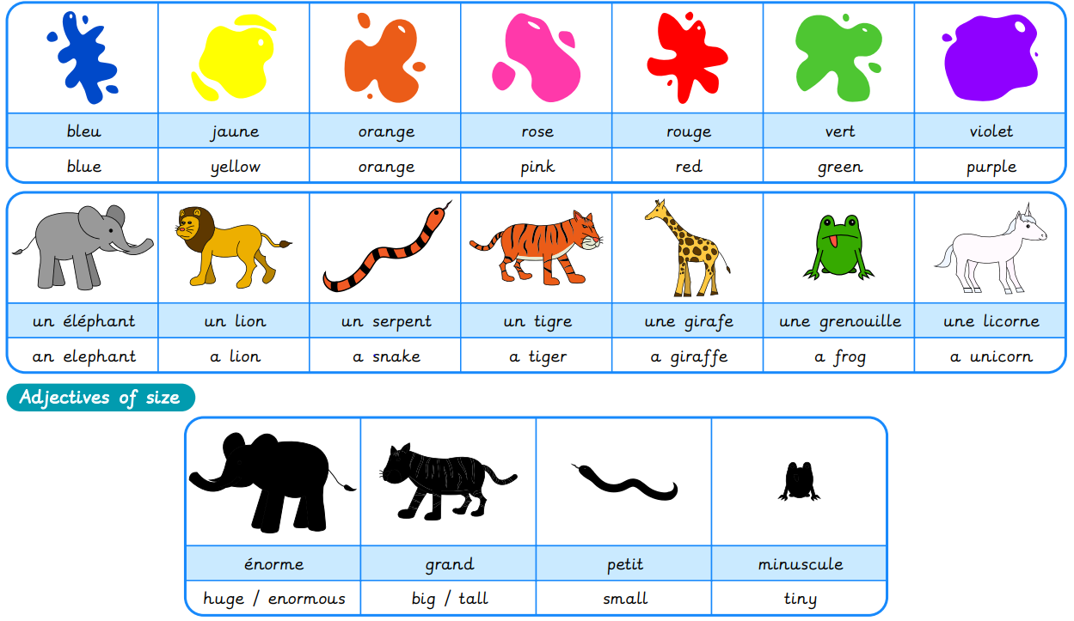

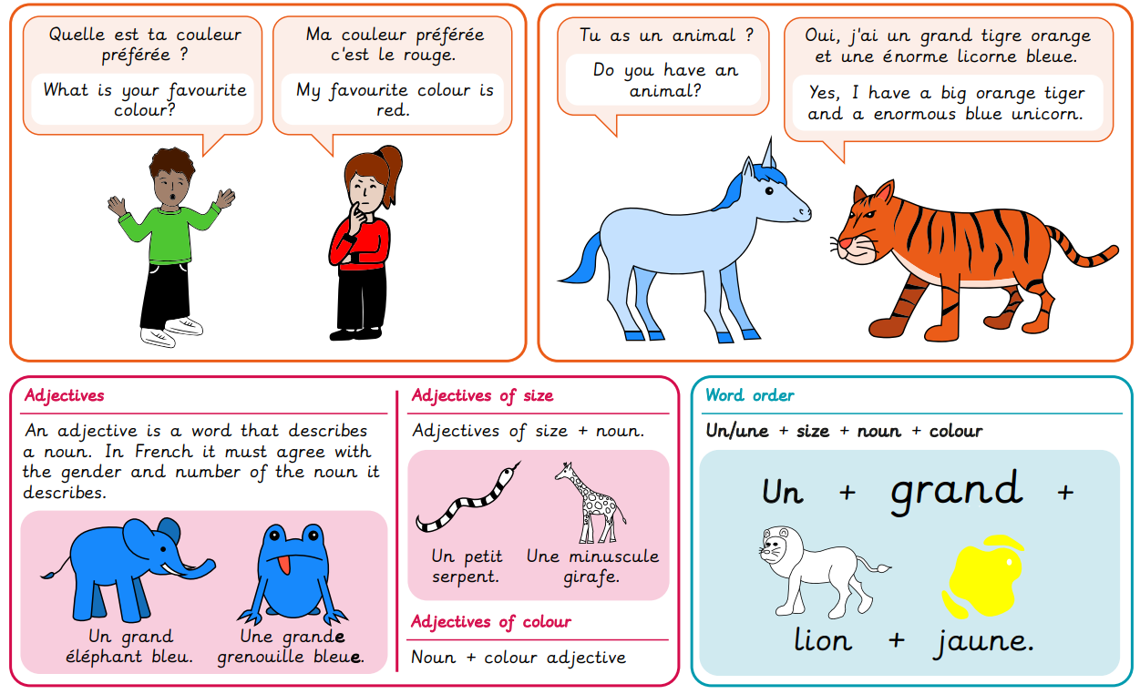

**Key Vocabulary**

**Year 3/4 Fabulous French Food**

